UNITED STATES

SECURITIES AND EXCHANGE COMMISSION

Washington, D.C. 20549

SCHEDULE 14A INFORMATION

Proxy Statement Pursuant to Section 14(a) of the Securities Exchange Act of 1934

Filed by the Registrant

Filed by a Party other than the Registrant

☒

☐

Check the appropriate box:

- Preliminary Proxy Statement

- Confidential, for Use of the Commission Only (as permitted by Rule 14a-6(e)(2))

- Definitive Proxy Statement

- Definitive Additional Materials

- Soliciting Material Pursuant to § 240.14a-12

VAXART, INC.

(Name of Registrant as Specified In Its Charter)

(Name of Person(s) Filing Proxy Statement if Other Than the Registrant)

Payment of Filing Fee (Check the appropriate box)

- No fee required.

- Fee paid previously with preliminary materials

- Fee computed on table in exhibit required by Item 25(b) per Exchange Act Rules 14a-6(i)(1) and 0-11.

Social media communications relating to Vaxart, Inc.’s upcoming annual meeting are provided below:

Corporate X

Today $VXRT announced an agreement with a group of shareholders to resolve our proxy contest, reflecting our commitment to strong corporate governance and shareholder engagement. We remain focused on the important milestones ahead.

Read more: bit.ly/3TccubY

Corporate LinkedIn

We are pleased to have reached an agreement with a group of shareholders to resolve our proxy contest, reflecting our commitment to strong corporate governance and shareholder engagement.

As Vaxart approaches a series of clinical, regulatory and operational milestones, we remain fully focused on executing our strategy and maximizing value as we work to validate our oral vaccine platform.

Our Board is confident that Vaxart has the leadership, expertise and focus needed to deliver on the opportunities ahead.

Read more: http://bit.ly/3TccubY


1

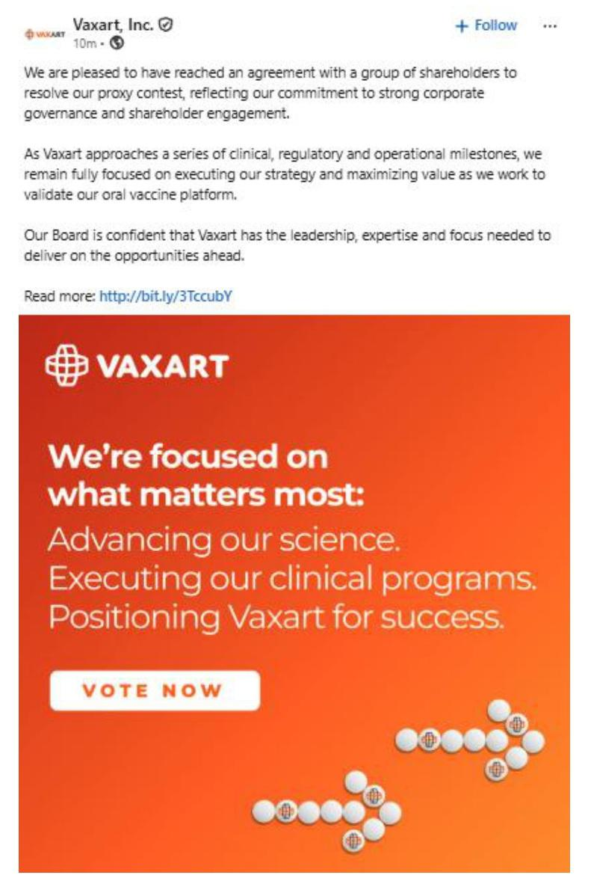

About Vaxart

Vaxart is a clinical-stage biotechnology company developing a range of oral recombinant vaccines based on its proprietary delivery platform. Vaxart vaccines are designed to be administered using pills that can be stored and shipped without refrigeration and eliminate the risk of needle-stick injury. Vaxart believes that its proprietary pill vaccine delivery platform is suitable to deliver recombinant vaccines, positioning the Company to develop oral versions of currently marketed vaccines and to design recombinant vaccines for new indications. Vaxart’s development programs currently include pill vaccines designed to protect against coronavirus, norovirus, and influenza, as well as a therapeutic vaccine for human papillomavirus (HPV), Vaxart’s first immune-oncology indication. Vaxart has filed broad domestic and international patent applications covering its proprietary technology and creations for oral vaccination using adenovirus and TLR3 agonists.

2

Cautionary Language Concerning Forward-Looking Statements

This communication contains forward-looking statements within the meaning of Section 27A of the Securities Act of 1933, as amended, and Section 21E of the Securities Exchange Act of 1934, as amended, which are subject to the “safe harbor” provisions created by those sections, that involve substantial risks and uncertainties. All statements, other than statements of historical facts, included in this communication regarding Vaxart’s strategy, prospects, plans and objectives, results from preclinical and clinical trials, commercialization agreements and licenses, and beliefs and expectations of management are forward-looking statements. These forward-looking statements may be accompanied by such words as “should,” “believe,” “could,” “potential,” “will,” “expected,” “anticipate,” “plan,” “target,” “seek,” “intend,” “may,” “predict,” “project,” “would,” and other words and terms of similar meaning. Actual results or events could differ materially from the plans, intentions, expectations, and projections disclosed in the forward-looking statements. Various important factors could cause actual results or events to differ materially from the forward-looking statements that Vaxart makes, including uncertainties inherent in research and development and other risks and uncertainties described in the “Risk Factors” sections of Vaxart’s most recent Annual Report on Form 10-K, as amended, and Quarterly Reports on Form 10-Q filed with the U.S. Securities and Exchange Commission. Vaxart undertakes no obligation to publicly update or revise any forward-looking statements, whether as a result of new information, future events, or otherwise, except as required by applicable law.

Investor Contact

Michael Fein

Campaign Management

(855) 264-1527

Media Contact

Aaron Palash / Adam Pollack

Joele Frank, Wilkinson Brimmer Katcher

(212) 355-4449

3

