UNITED STATES

SECURITIES AND EXCHANGE COMMISSION

Washington, D.C. 20549

SCHEDULE 14A INFORMATION

Proxy Statement Pursuant to Section 14(a) of the Securities Exchange Act of 1934

Filed by the Registrant

Filed by a Party other than the Registrant

Check the appropriate box:

☒

☐

- Preliminary Proxy Statement

- Confidential, for Use of the Commission Only (as permitted by Rule 14a-6(e)(2))

- Definitive Proxy Statement

- Definitive Additional Materials

- Soliciting Material Pursuant to § 240.14a-12

VAXART, INC.

(Name of Registrant as Specified In Its Charter)

(Name of Person(s) Filing Proxy Statement if Other Than the Registrant)

Payment of Filing Fee (Check the appropriate box)

- No fee required.

- Fee paid previously with preliminary materials

- Fee computed on table in exhibit required by Item 25(b) per Exchange Act Rules 14a-6(i)(1) and 0-11.

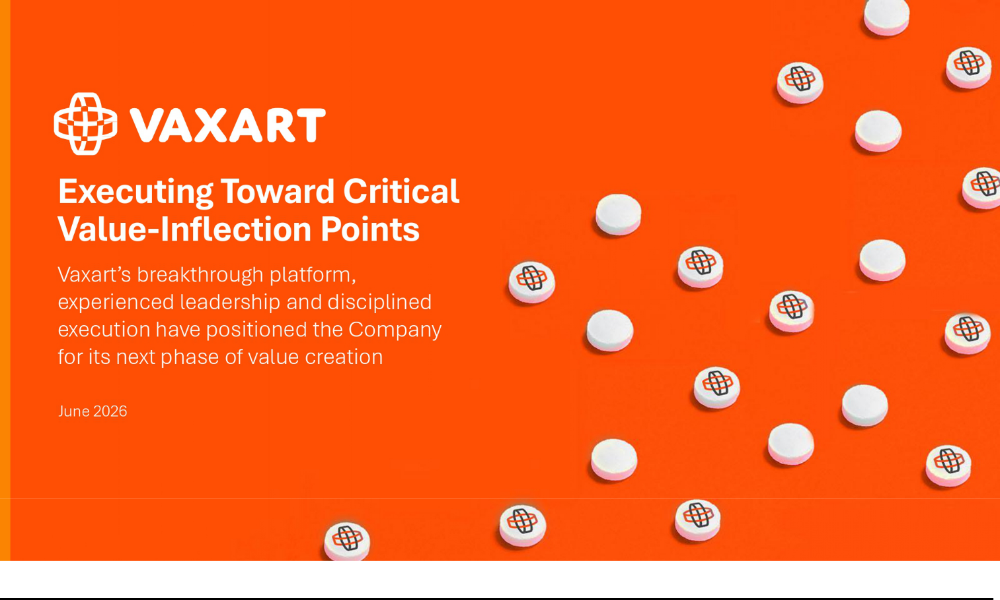

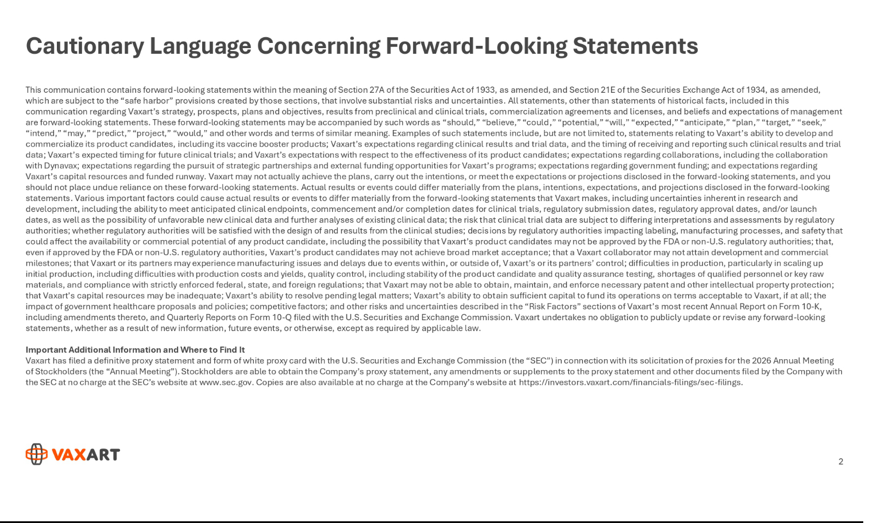

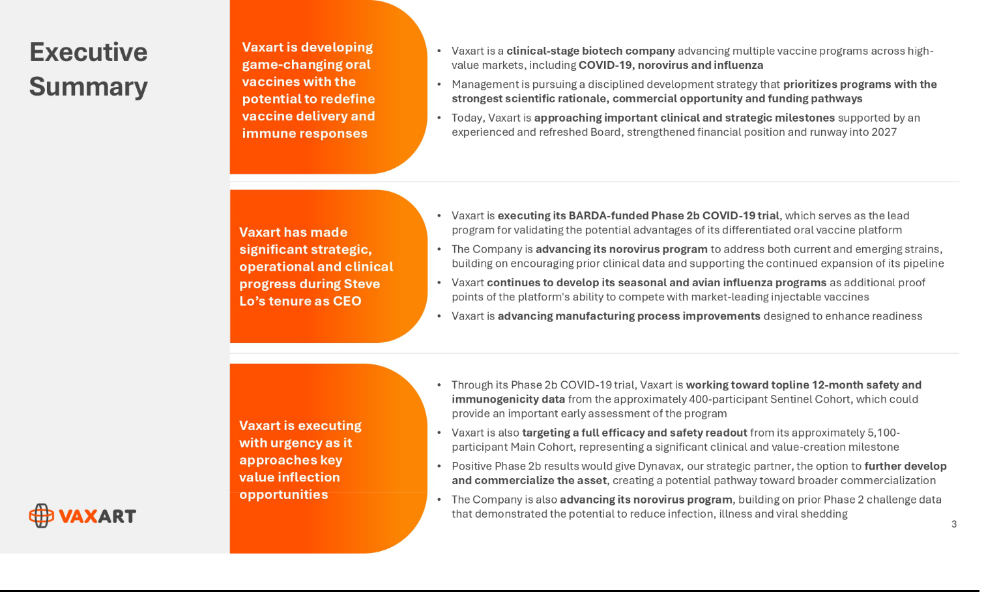

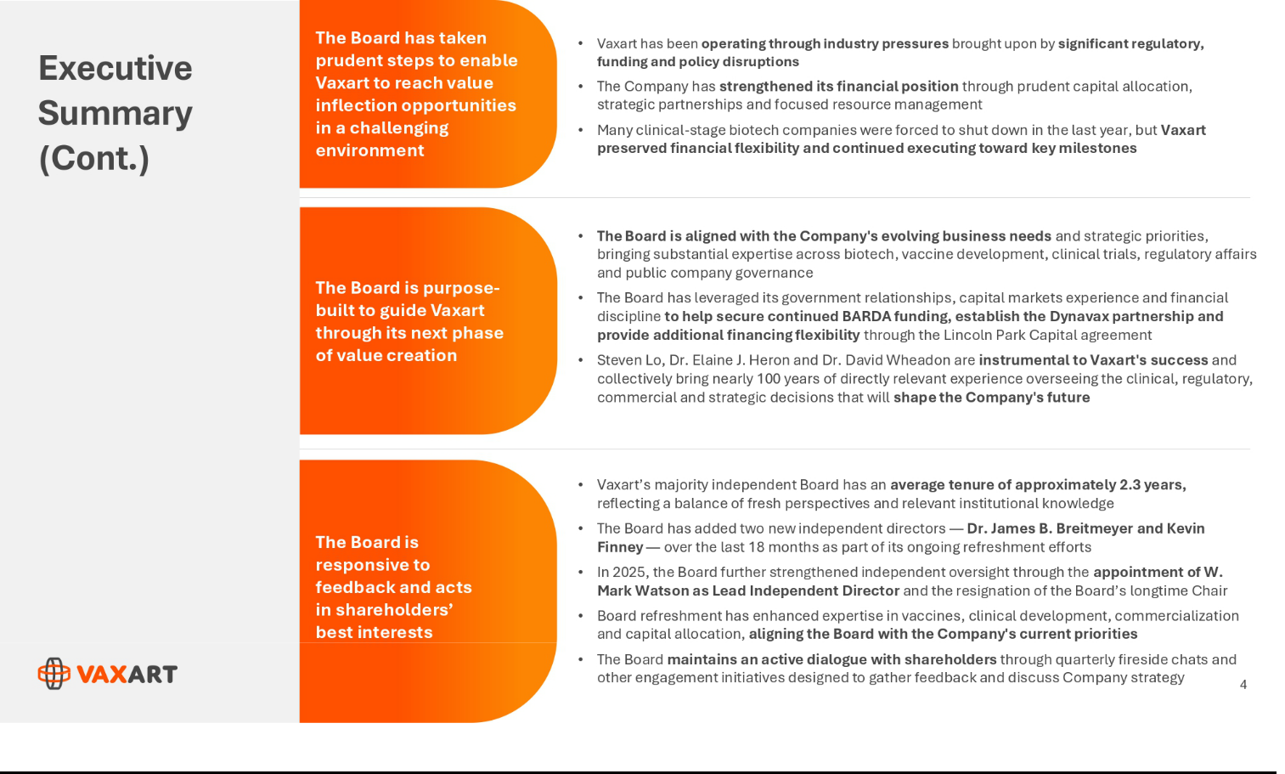

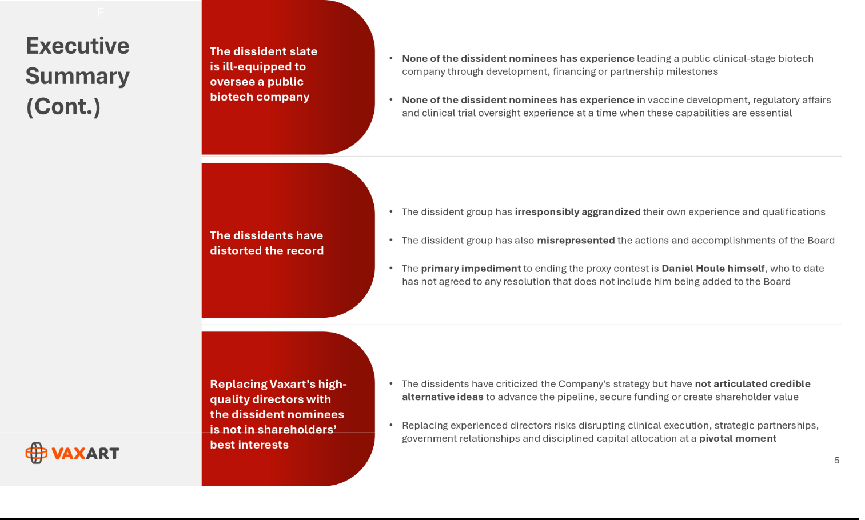

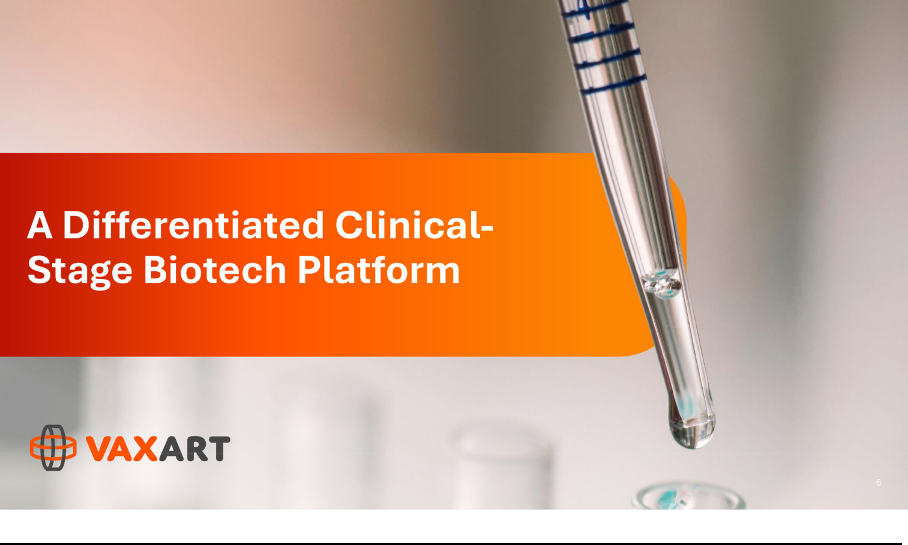

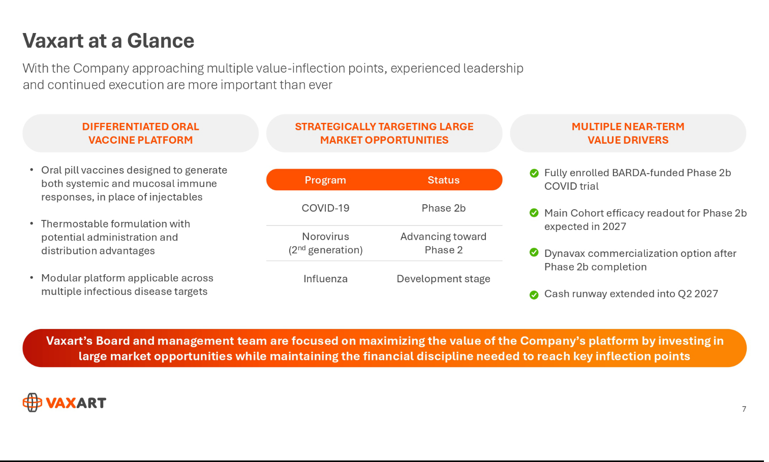

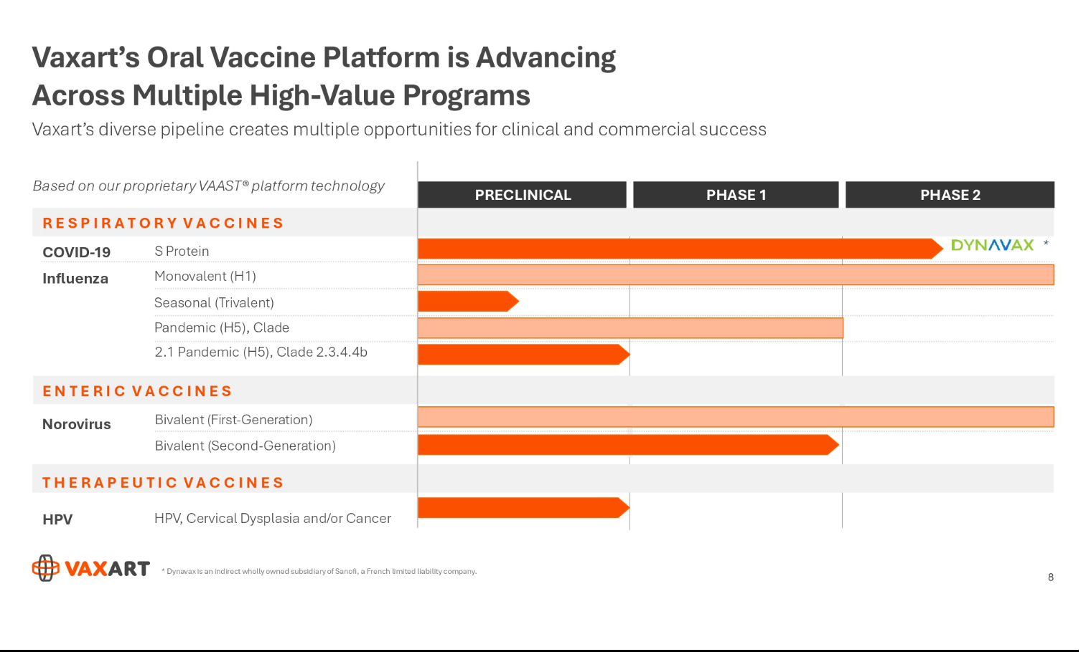

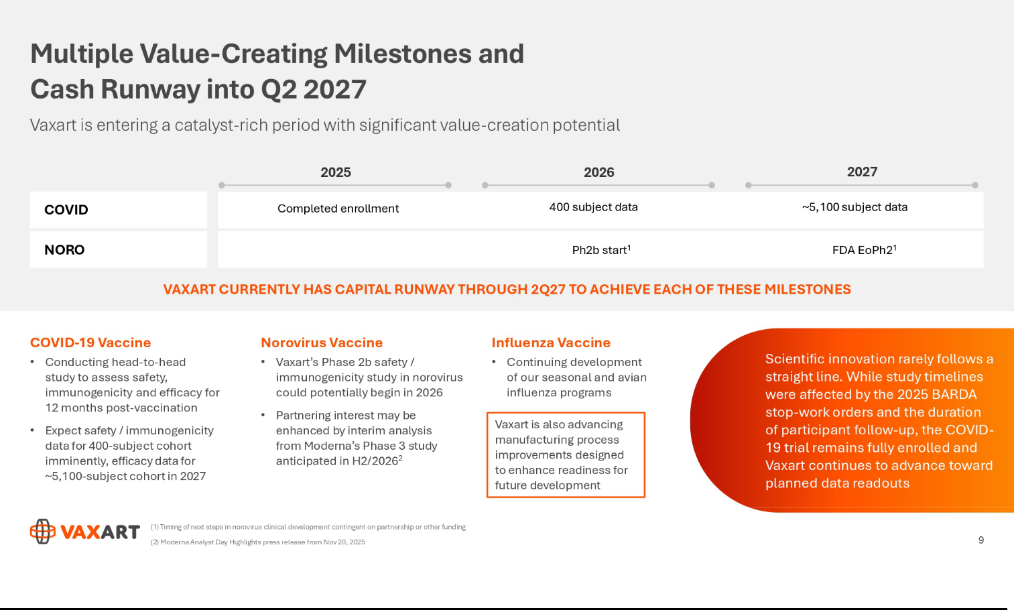

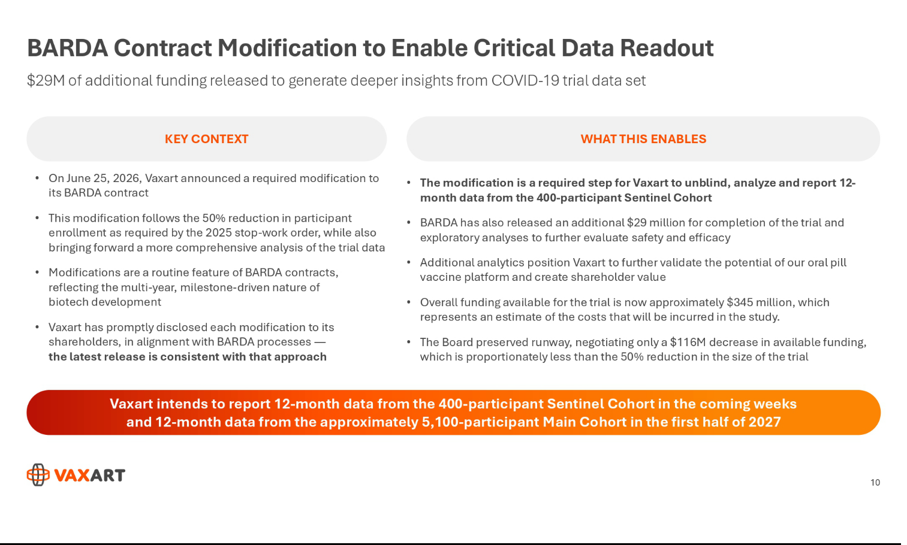

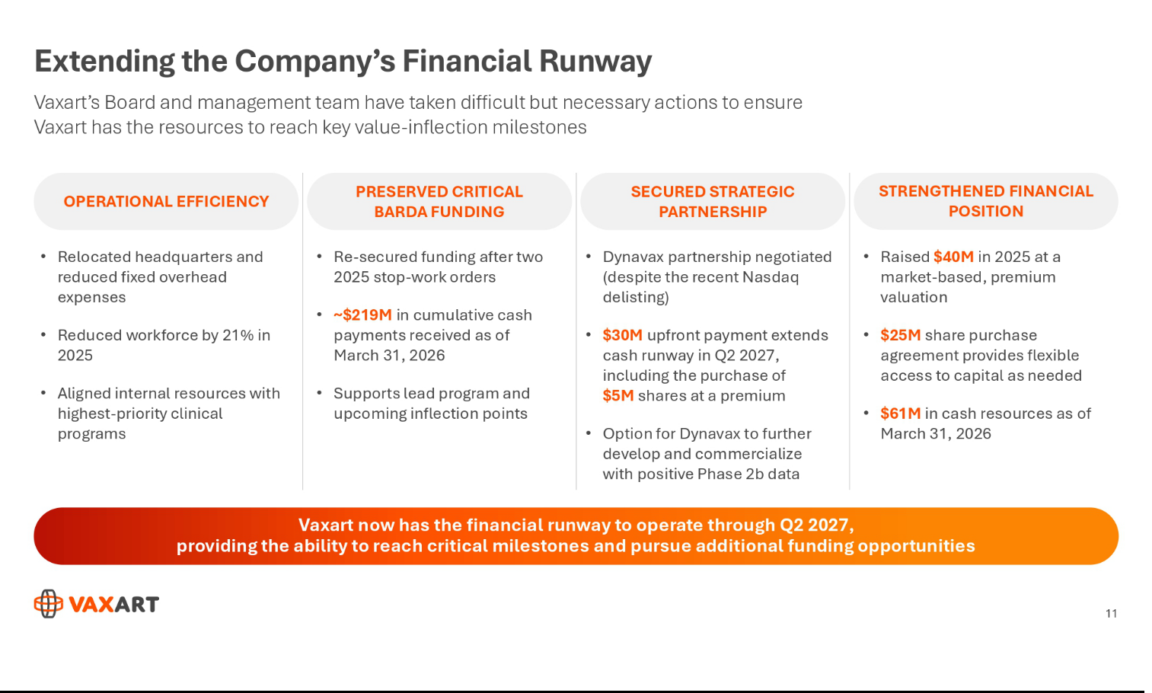

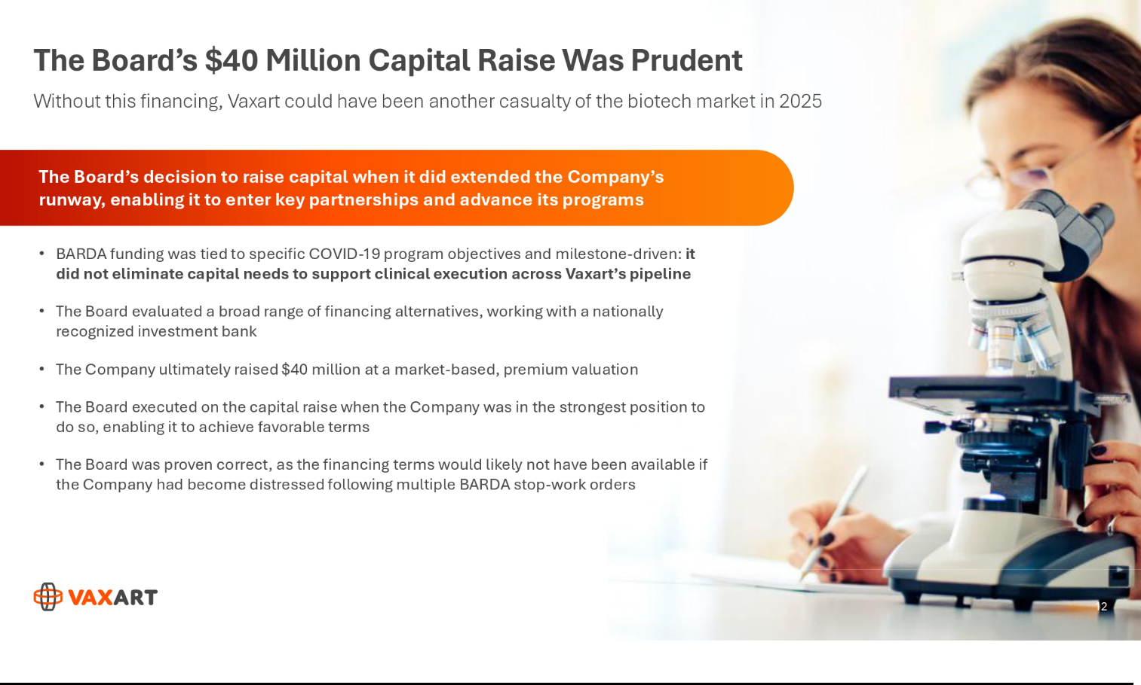

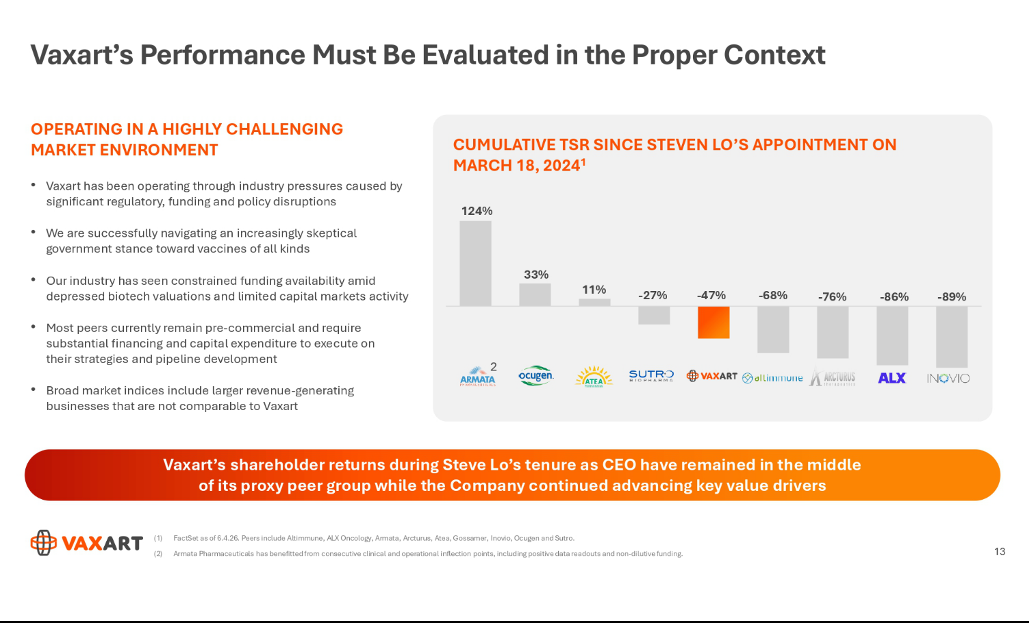

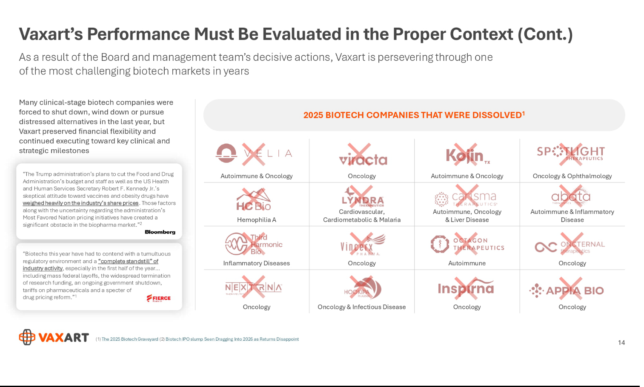

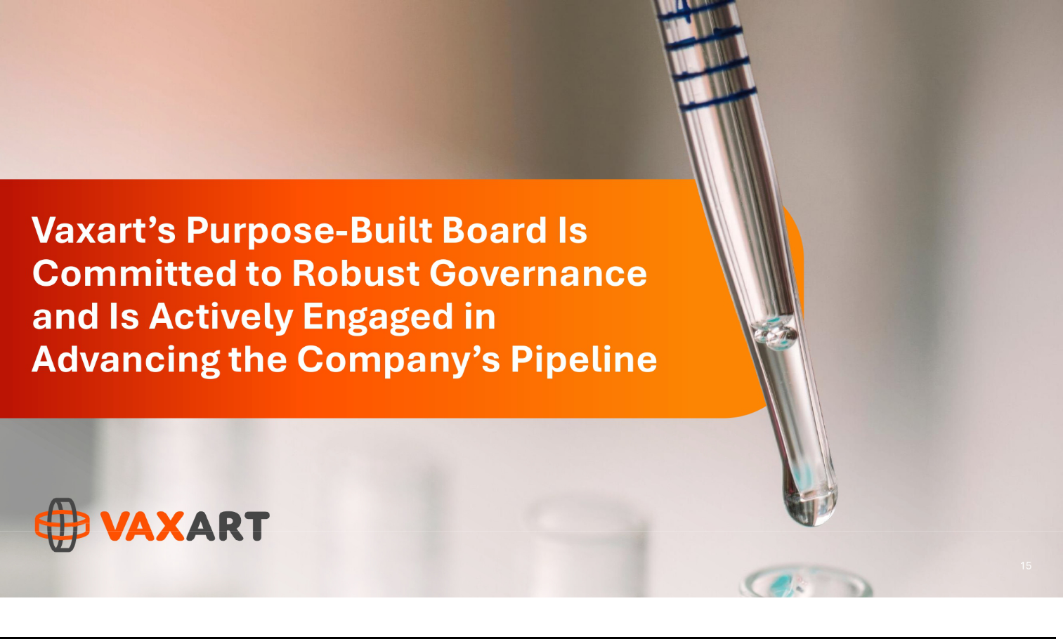

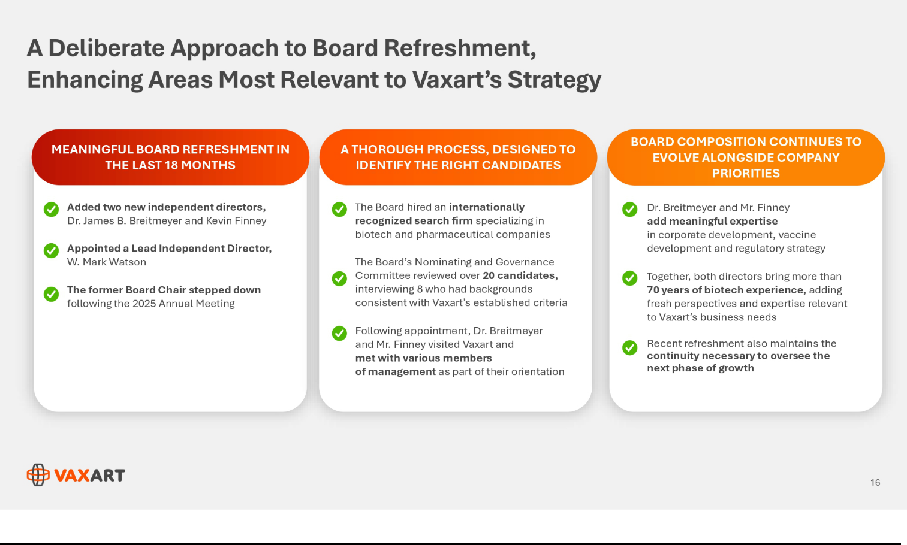



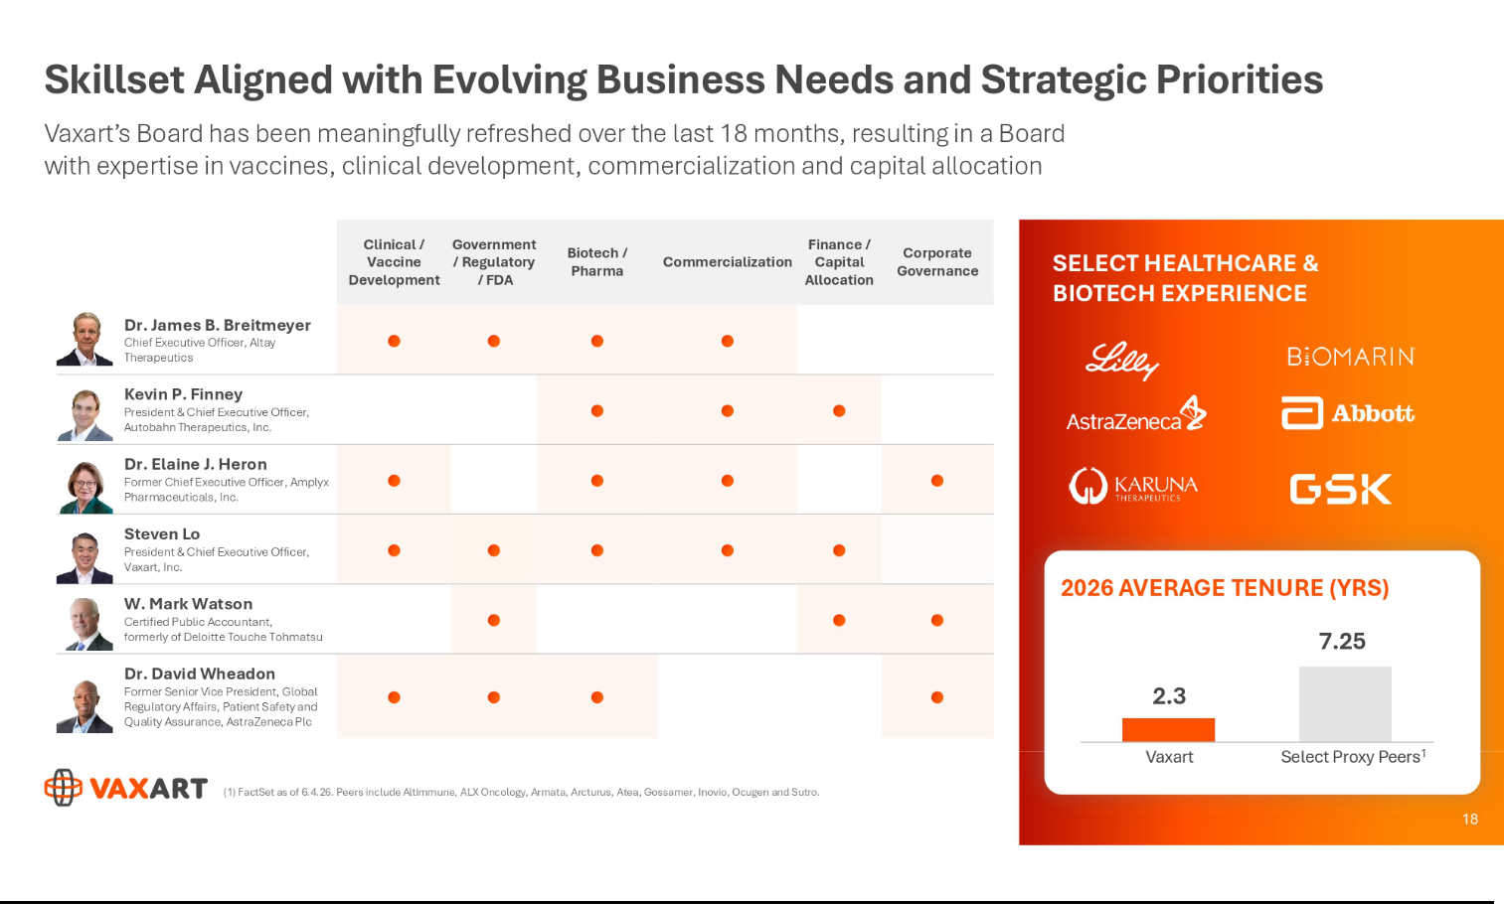

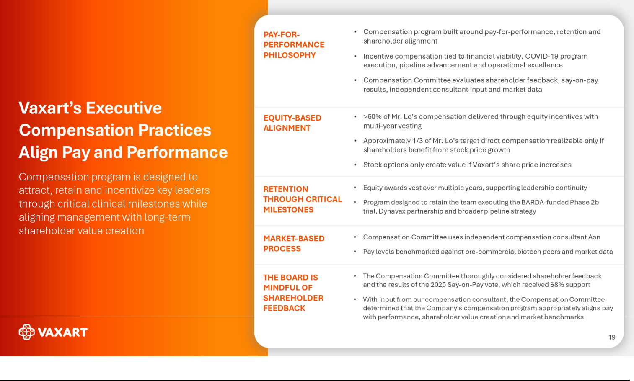

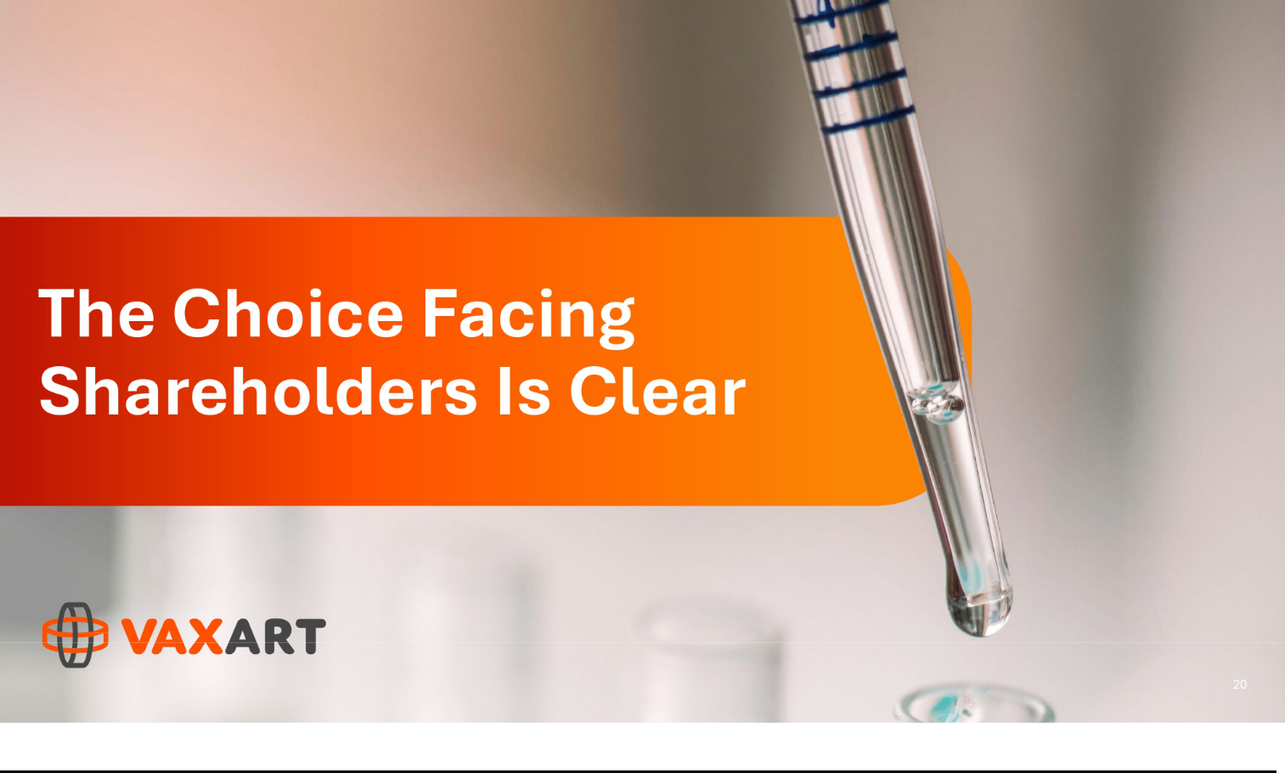

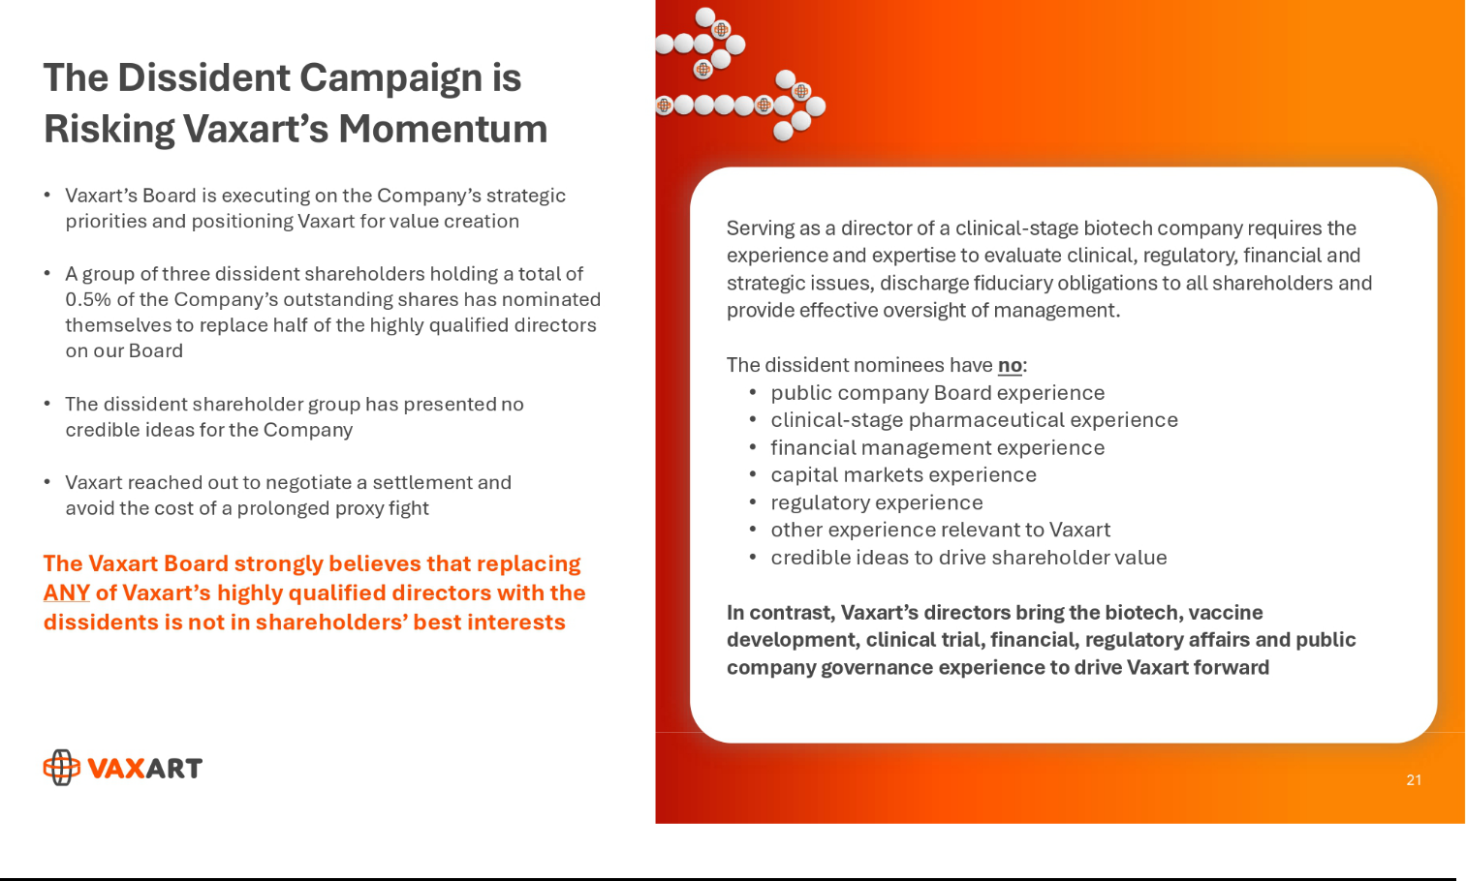

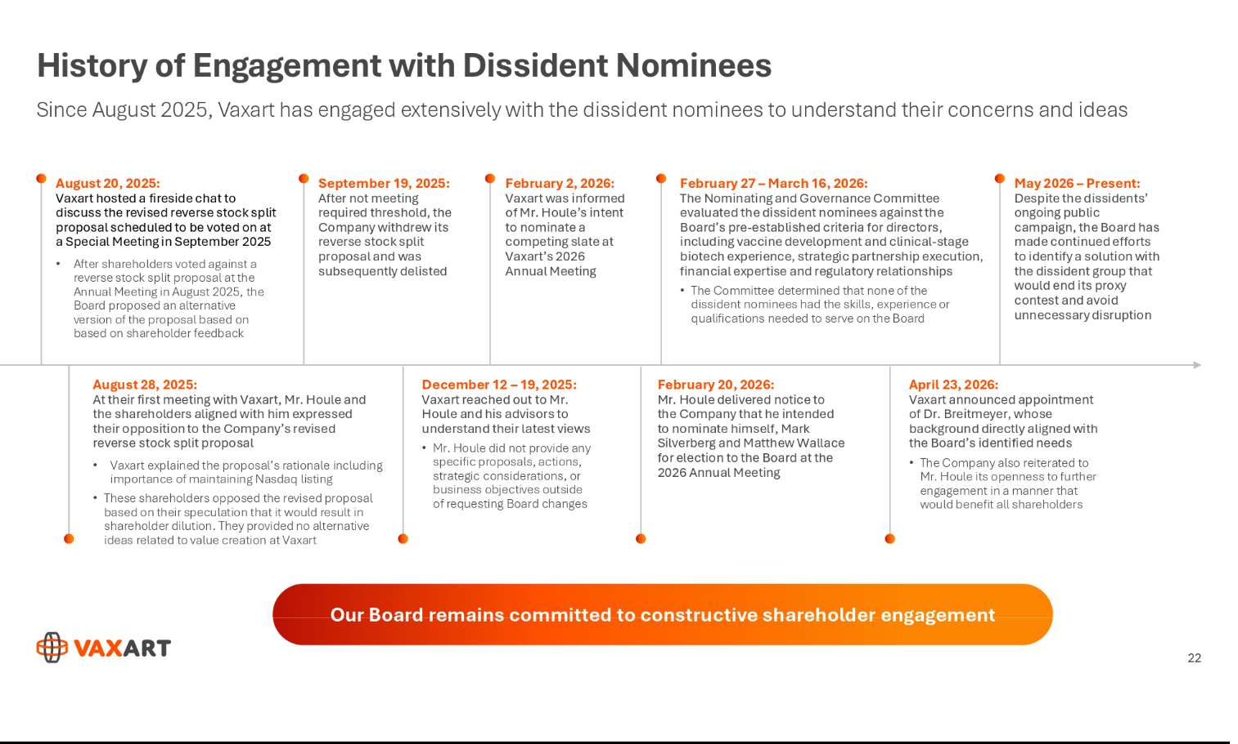

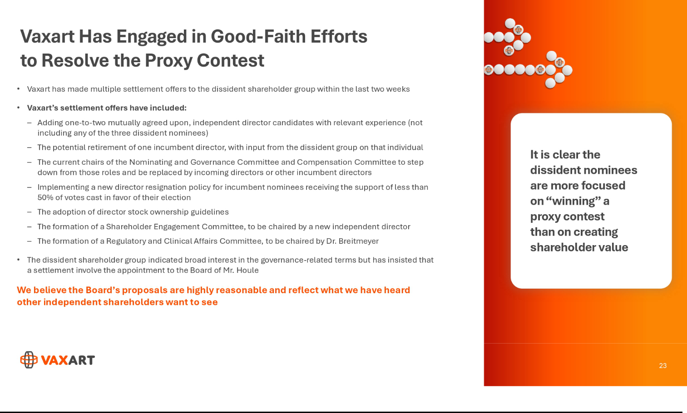

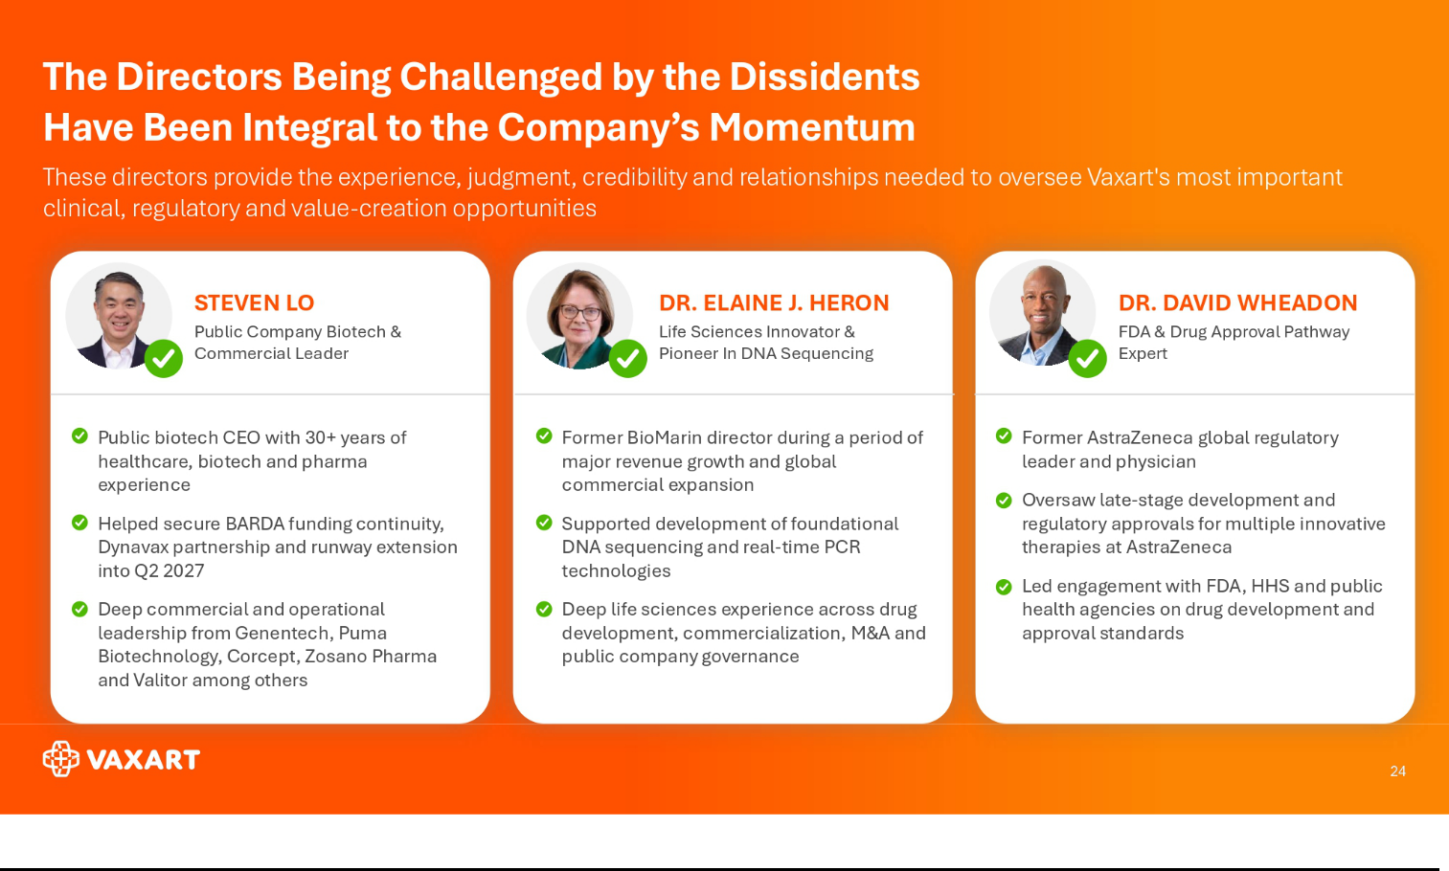

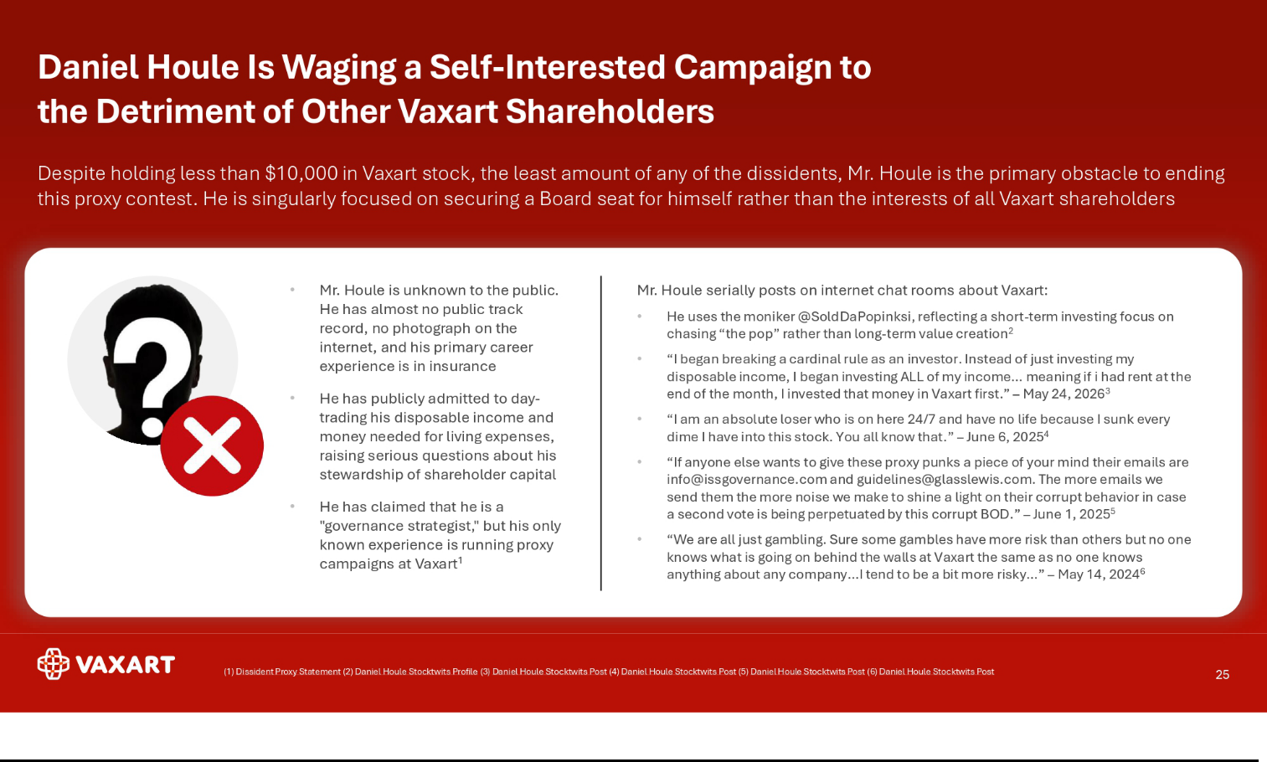

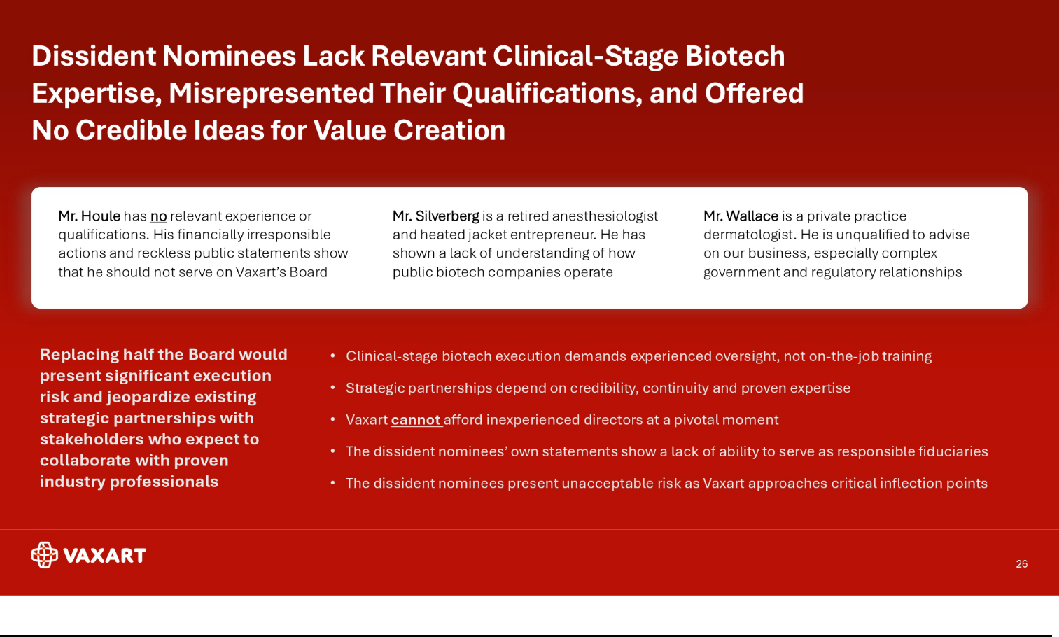

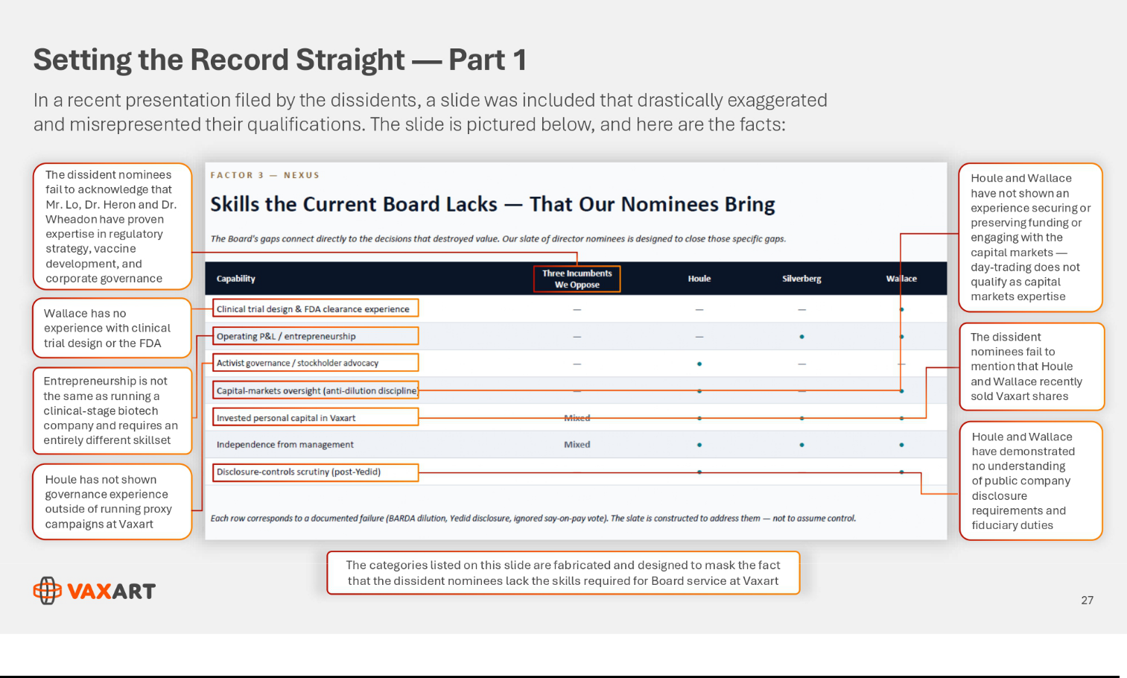

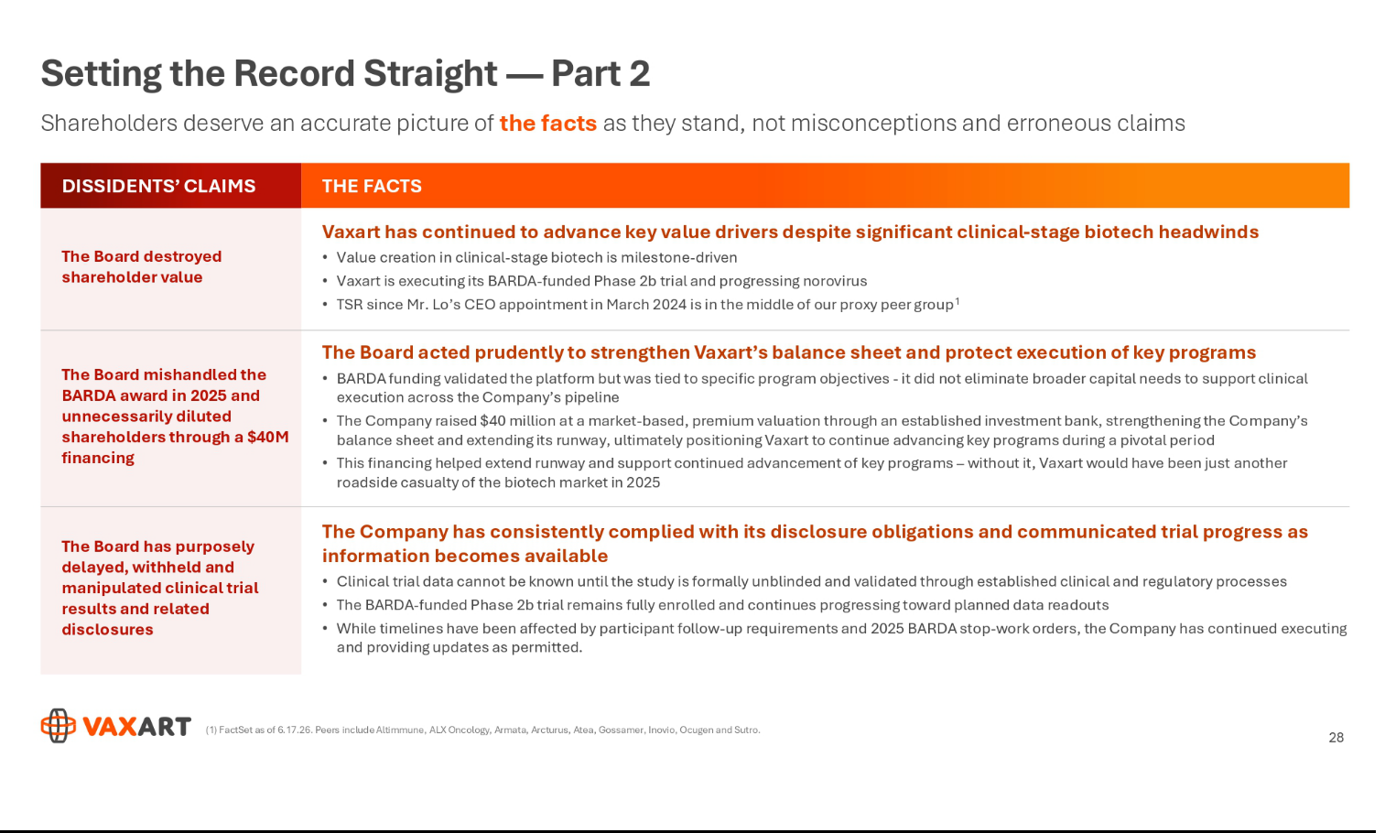

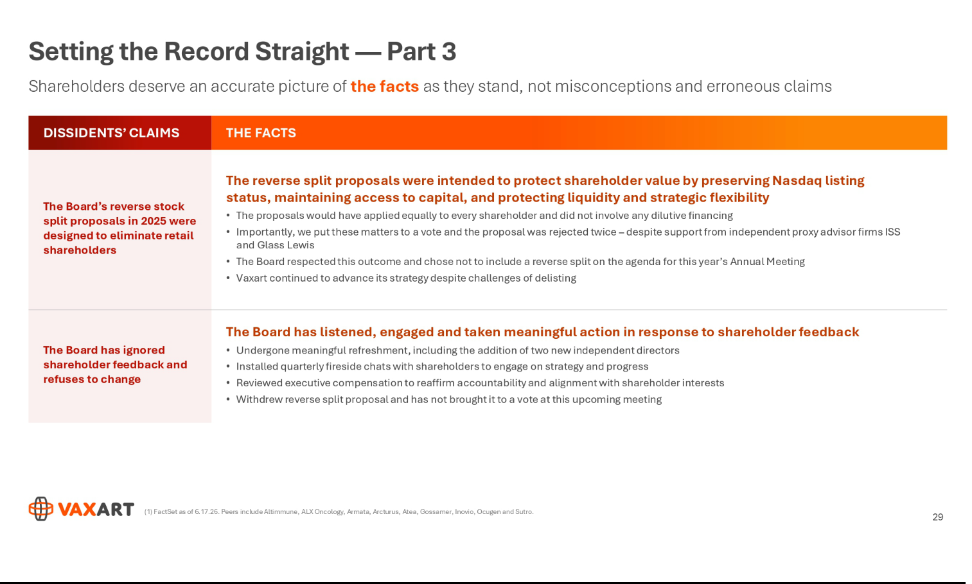

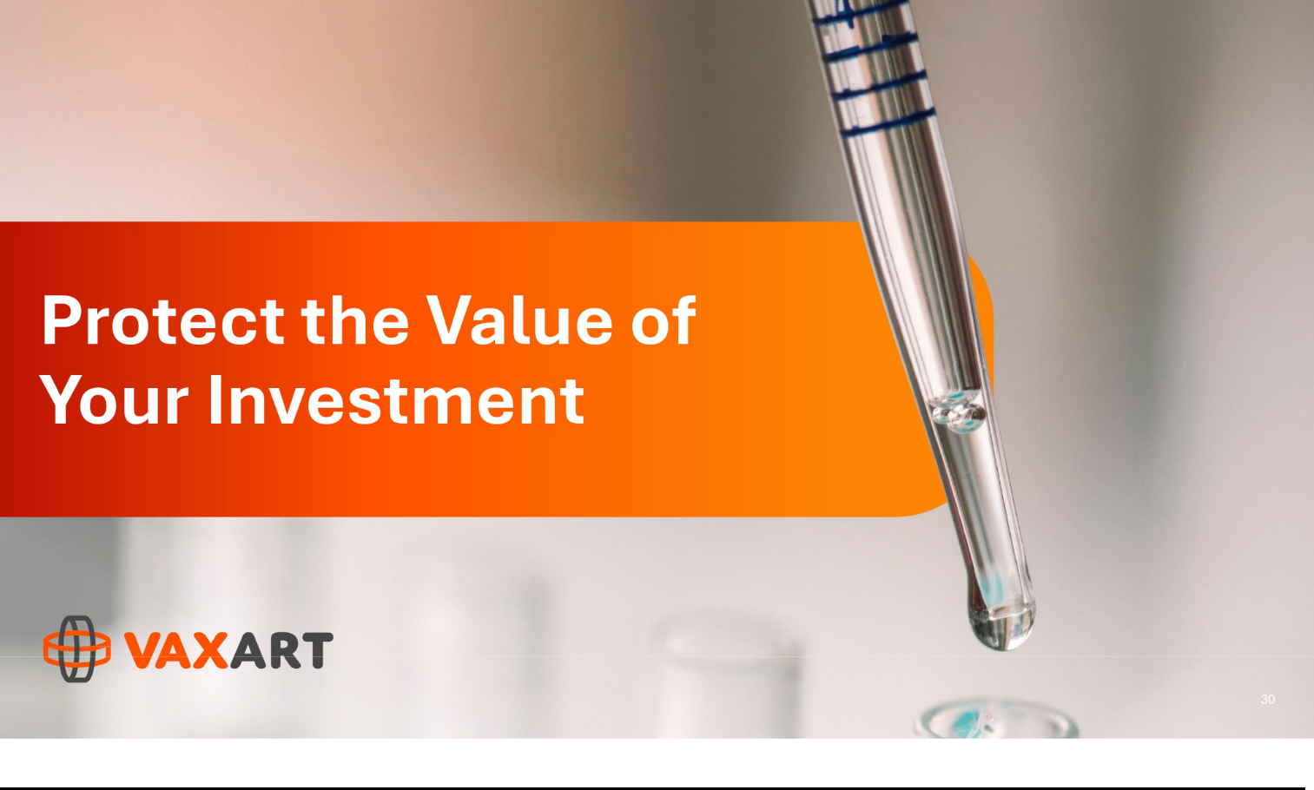

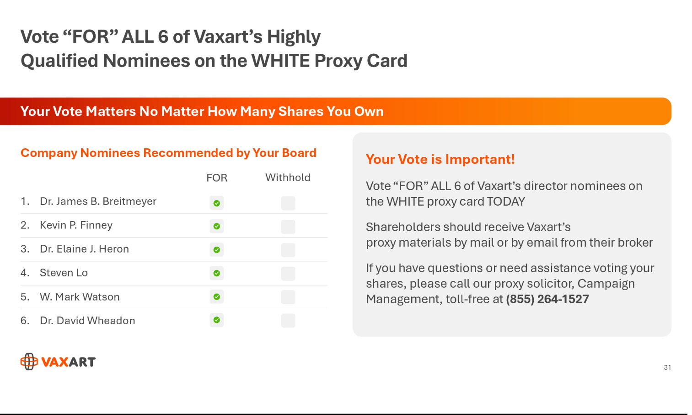

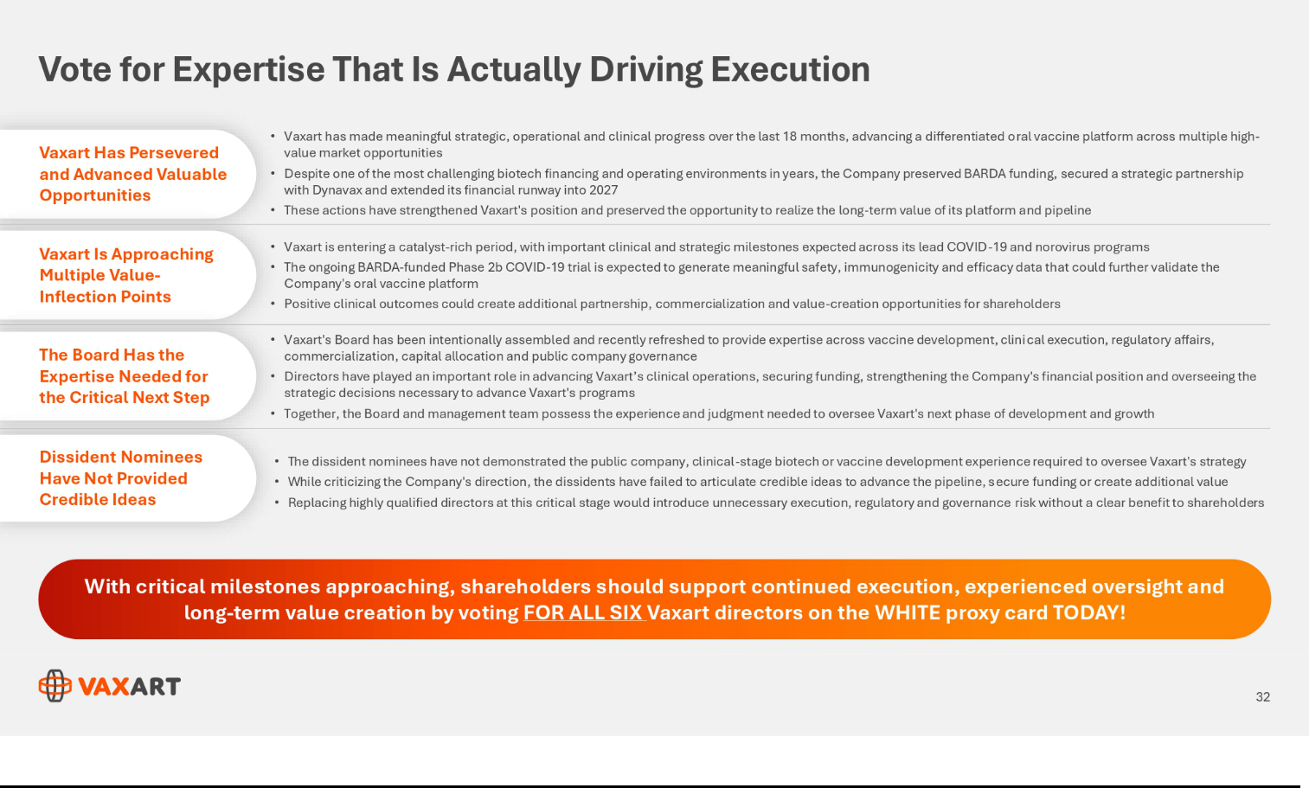

About Vaxart

Vaxart is a clinical-stage biotechnology company developing a range of oral recombinant vaccines based on its proprietary delivery platform. Vaxart vaccines are designed to be administered using pills that can be stored and shipped without refrigeration and eliminate the risk of needle-stick injury. Vaxart believes that its proprietary pill vaccine delivery platform is suitable to deliver recombinant vaccines, positioning the Company to develop oral versions of currently marketed vaccines and to design recombinant vaccines for new indications. Vaxart’s development programs currently include pill vaccines designed to protect against coronavirus, norovirus, and influenza, as well as a therapeutic vaccine for human papillomavirus (HPV), Vaxart’s first immune-oncology indication. Vaxart has filed broad domestic and international patent applications covering its proprietary technology and creations for oral vaccination using adenovirus and TLR3 agonists.

Cautionary Language Concerning Forward-Looking Statements

This communication contains forward-looking statements within the meaning of Section 27A of the Securities Act of 1933, as amended, and Section 21E of the Securities Exchange Act of 1934, as amended, which are subject to the “safe harbor” provisions created by those sections, that involve substantial risks and uncertainties. All statements, other than statements of historical facts, included in this communication regarding Vaxart’s strategy, prospects, plans and objectives, results from preclinical and clinical trials, commercialization agreements and licenses, and beliefs and expectations of management are forward-looking statements. These forward-looking statements may be accompanied by such words as “should,” “believe,” “could,” “potential,” “will,” “expected,” “anticipate,” “plan,” “target,” “seek,” “intend,” “may,” “predict,” “project,” “would,” and other words and terms of similar meaning. Examples of such statements include, but are not limited to, statements relating to Vaxart’s ability to develop and commercialize its product candidates, including its vaccine booster products; Vaxart’s expectations regarding clinical results and trial data, and the timing of receiving and reporting such clinical results and trial data; Vaxart’s expected timing for future clinical trials; and Vaxart’s expectations with respect to the effectiveness of its product candidates; expectations regarding collaborations, including the collaboration with Dynavax; expectations regarding the pursuit of strategic partnerships and external funding opportunities for Vaxart’s programs; expectations regarding government funding; and expectations regarding Vaxart’s capital resources and funded runway. Vaxart may not actually achieve the plans, carry out the intentions, or meet the expectations or projections disclosed in the forward-looking statements, and you should not place undue reliance on these forward-looking statements. Actual results or events could differ materially from the plans, intentions, expectations, and projections disclosed in the forward-looking statements. Various important factors could cause actual results or events to differ materially from the forward-looking statements that Vaxart makes, including uncertainties inherent in research and development, including the ability to meet anticipated clinical endpoints, commencement and/or completion dates for clinical trials, regulatory submission dates, regulatory approval dates, and/or launch dates, as well as the possibility of unfavorable new clinical data and further analyses of existing clinical data; the risk that clinical trial data are subject to differing interpretations and assessments by regulatory authorities; whether regulatory authorities will be satisfied with the design of and results from the clinical studies; decisions by regulatory authorities impacting labeling, manufacturing processes, and safety that could affect the availability or commercial potential of any product candidate, including the possibility that Vaxart’s product candidates may not be approved by the FDA or non-U.S. regulatory authorities; that, even if approved by the FDA or non-U.S. regulatory authorities, Vaxart’s product candidates may not achieve broad market acceptance; that a Vaxart collaborator may not attain development and commercial milestones; that Vaxart or its partners may experience manufacturing issues and delays due to events within, or outside of, Vaxart’s or its partners’ control; difficulties in production, particularly in scaling up initial production, including difficulties with production costs and yields, quality control, including stability of the product candidate and quality assurance testing, shortages of qualified personnel or key raw materials, and compliance with strictly enforced federal, state, and foreign regulations; that Vaxart may not be able to obtain, maintain, and enforce necessary patent and other intellectual property protection; that Vaxart’s capital resources may be inadequate; Vaxart’s ability to resolve pending legal matters; Vaxart’s ability to obtain sufficient capital to fund its operations on terms acceptable to Vaxart, if at all; the impact of government healthcare proposals and policies; competitive factors; and other risks and uncertainties described in the “Risk Factors” sections of Vaxart’s most recent Annual Report on Form 10-K, including amendments thereto, and Quarterly Reports on Form 10-Q filed with the U.S. Securities and Exchange Commission. Vaxart undertakes no obligation to publicly update or revise any forward-looking statements, whether as a result of new information, future events, or otherwise, except as required by applicable law.

Important Additional Information and Where to Find It

Vaxart has filed a definitive proxy statement and form of white proxy card with the U.S. Securities and Exchange Commission (the “SEC”) in connection with its solicitation of proxies for the 2026 Annual Meeting of Stockholders (the “Annual Meeting”). STOCKHOLDERS OF THE COMPANY ARE STRONGLY ENCOURAGED TO READ SUCH PROXY STATEMENT (INCLUDING ANY AMENDMENTS OR SUPPLEMENTS THERETO), THE ACCOMPANYING WHITE PROXY CARD AND ALL OTHER DOCUMENTS FILED WITH, OR FURNISHED TO, THE SEC IN CONNECTION WITH THE ANNUAL MEETING CAREFULLY AND IN THEIR ENTIRETY WHEN THEY BECOME AVAILABLE AS THEY WILL CONTAIN IMPORTANT INFORMATION ABOUT THE ANNUAL MEETING. Stockholders are able to obtain the Company’s proxy statement, any amendments or supplements to the proxy statement and other documents filed by the Company with the SEC at no charge at the SEC’s website at www.sec.gov. Copies are also available at no charge at the Company’s website at https://investors.vaxart.com/financials-filings/sec-filings.

Investor Contact

Michael Fein

Campaign Management

(855) 264-1527

Media Contact

Aaron Palash / Adam Pollack

Joele Frank, Wilkinson Brimmer Katcher

(212) 355-4449

